What will we be learning?  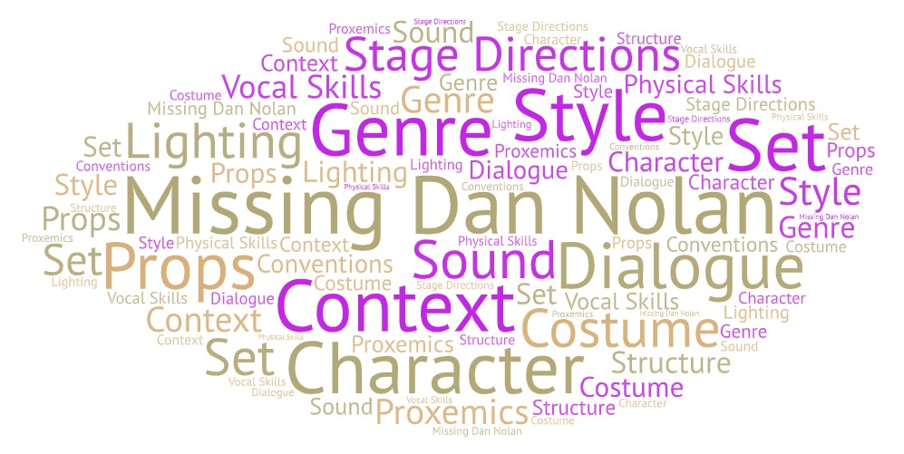 | Why this? Why now?  Year 9  In preparation for GCSE Drama you will study a set play practically and theoretically.  Year 10  You will practically and theoretically study the set play in preparation for your written examination which will take place in year 11.  Future Learning –  A Level Drama and Theatre Studies  Sweeney Todd by Christopher Bond  Frankenstein by Nick Dear  Othello by William Shakespeare  Key Words:  Social Context  Historical Context  Cultural Context  Genre  Structure  Characters  Form  Styles  Plot  Dialogue  Stage directions  Set  Props  Costume  Lighting  Sound  Conventions
What will we learn?
AO3 - Demonstrate knowledge and understanding of how drama and theatre is developed and performed.
- The contexts of the text – social, historical (time set, and period written) and cultural.
- The theatrical conventions of the period in which the text was created.
- The genre of the play.
- The structure of the play.
- The characters.
- The form and style.
- The theatrical setting.
- The plot and subplot.
- The dialogue.
- The stage directions.
- How meaning is created through the use of performance space and spatial awareness on the stage.
- The relationships between the performer and the audience.
- The design of the: set, props, costume, lighting and sound.
- An actors vocal and physical interpretation of the character.

What opportunities are there for wider study?
LAMDA Performance Exams – individual and group tuition at school.
Senior Drama Club (Year 8, 9, 10 and 11) – to perform in projects such as ‘National Theatre Connections Plays’
Theatre Trips – Visit a local theatre or head to the West End in London to see a live performance.
Visit the National Theatre Live website to stream a live theatre performance.
How will I be assessed?
In rehearsal and in your final performance.

Creating – Taking own initiative in experimenting with a range of scripted techniques and devices. Presenting them in a creative and imaginative way.

Performance - Create a clearly defined character which is sustained in a performance piece. The role will demonstrate creativity and imagination.

Responding – Use technical terms with confidence when talking or writing about drams you have seen or participated in. For example, ‘the use of a high pitched voice showed the character was really excited’.

